Exception Handling

Exception Handling
What is Exception?
An exception is an event that occurs during the execution of a program that disrupts the normal flow of instructions. These exceptions can occur for various reasons, such as invalid user input, file not found, or division by zero. When an exception occurs, it is typically represented by an object of a subclass of the java.lang.Exception class.
What is Exception?
Exception Handling is a mechanism to handle runtime errors such as ClassNotFoundException, IOException, SQLException, RemoteException, etc.
- Exception হলো এমন একটি সমস্যা যা প্রোগ্রাম চলার সময় ঘটে এবং স্বাভাবিক কার্যপ্রবাহকে ব্যাহত করে।
- Exception Handling হলো সেই সমস্যাকে ধরার ও সমাধান করার প্রক্রিয়া।
The core advantage of exception handling is to maintain the normal flow of the application. An exception normally disrupts the normal flow of the application; that is why we need to handle exceptions.

- statement 1;
- statement 2;
- statement 3;
- statement 4;
- statement 5;//exception occurs
- statement 6;
- statement 7;
- statement 8;
- statement 9;
- statement 10;
Suppose there are 10 statements in a Java program and an exception occurs at statement 5; the rest of the code will not be executed, i.e., statements 6 to 10 will not be executed. However, when we perform exception handling, the rest of the statements will be executed. That is why we use exception handling

Hierarchy of Java Exception classes:
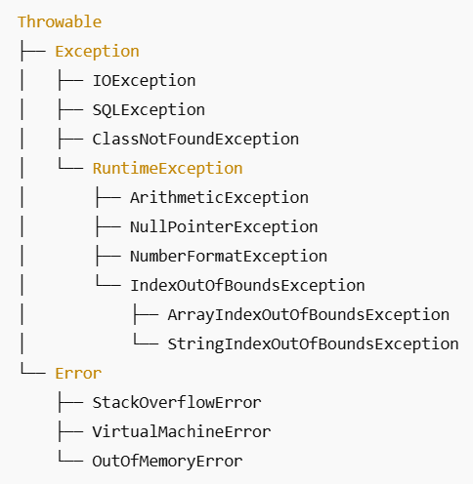
The java.lang.Throwable class is the root class of Java Exception hierarchy inherited by two subclasses: Exception and Error. The hierarchy of Java Exception classes is given below:
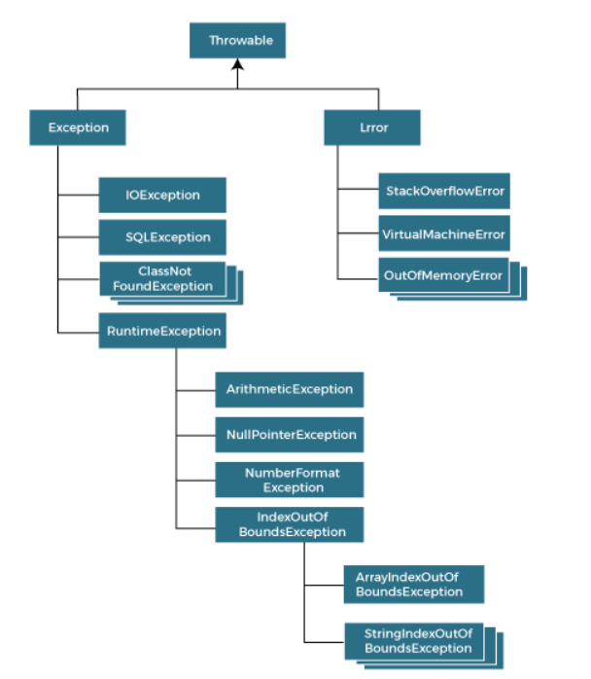
🌳 Root Class: Throwable
Java-তে সব Exception এবং Error এর মূল ক্লাস হলো Throwable।

🔹 Throwable-এর দুটি প্রধান শাখা:
- Exception – এগুলো হলো এমন সমস্যা যেগুলো প্রোগ্রামার হ্যান্ডেল করতে পারেন, যেমন IOException, NullPointerException ইত্যাদি।
- Error – এগুলো হলো জটিল বা সিস্টেম লেভেলের সমস্যা, যেগুলো হ্যান্ডেল করা কঠিন বা অবাঞ্চিত, যেমন OutOfMemoryError, StackOverflowError।

1️. Exception শ্রেণি (Handled বা Checked করা যায়)
📦 Checked Exceptions -> compile time
এইগুলো কম্পাইল টাইমে চেক করা হয়। এগুলো হ্যান্ডেল না করলে কম্পাইল টাইম error দেয়।
This means that the compiler verifies that the code handles these exceptions either by catching them or declaring them in the method signature using the throws keyword.
- IOException
- SQLException
- ClassNotFoundException
📦 Unchecked Exceptions (RuntimeException এর subclass): -> runtime, not compile time.
এইগুলো runtime-এ ঘটে, এবং হ্যান্ডেল না করলেও কোড কম্পাইল হয়।
These exceptions usually occur due to programming errors, such as logic errors or incorrect assumptions in the code. They do not need to be declared in the method signature using the throws keyword, making it optional to handle them.
- RuntimeException
  - ArithmeticException → যেমন 10 / 0
  - NullPointerException → null reference access করলে
  - NumberFormatException → String থেকে number রূপান্তর ভুল
  - IndexOutOfBoundsException
    - ArrayIndexOutOfBoundsException → array এর বাইরে অ্যাক্সেস
    - StringIndexOutOfBoundsException → string index ভুল

2️. Error শ্রেণি (সিস্টেম সংক্রান্ত জটিল সমস্যা)
এইগুলো সাধারণত প্রোগ্রামার হ্যান্ডেল করেন না।
- StackOverflowError → recursive call বেশি হলে stack overflow হয়
- OutOfMemoryError → JVM মেমোরি শেষ হলে
- VirtualMachineError → JVM সম্পর্কিত বড় সমস্যা

Types of Java Exceptions:
In Java, exceptions are categorized into two main types: checked exceptions and unchecked exceptions. Additionally, there is a third category known as errors. Let's delve into each of these types:
- Checked Exception
- Unchecked Exception
- Error
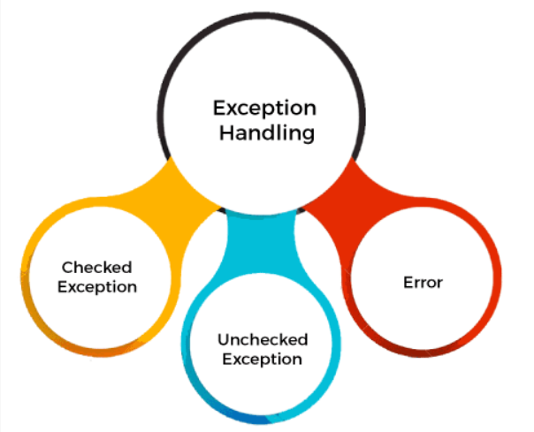

1. Checked Exceptions: -> Compile time
This means that the compiler verifies that the code handles these exceptions either by catching them or declaring them in the method signature using the throws keyword.

2. Unchecked Exceptions: -> Runtime Exceptions
These exceptions usually occur due to programming errors, such as logic errors or incorrect assumptions in the code. They do not need to be declared in the method signature using the throws keyword, making it optional to handle them.

3. Errors:
Error হচ্ছে এমন সমস্যা যা অ্যাপলিকেশনের নিয়ন্ত্রণের বাইরে, এবং সাধারণভাবে এগুলো catch বা handle করার প্রয়োজন নেই (বা করা উচিত না)।
এগুলো সাধারণত ঘটে:
- JVM বা সিস্টেমের ব্যর্থতায়
- মেমোরি সমস্যা
- ক্লাস লোড সংক্রান্ত জটিলতায়
⚠️ Error-এর উদাহরণ:
1. OutOfMemoryError
📌 কি কারণে হয়:
যখন JVM এর মেমোরি শেষ হয়ে যায়, তখন এই error আসে।
2. StackOverflowError
📌 কি কারণে হয়:
যখন অত্যাধিক recursion হয়, অর্থাৎ একটি মেথড বারবার নিজেকেই কল করে, তখন স্ট্যাক মেমোরি ফুরিয়ে যায়।
3. NoClassDefFoundError
📌 কি কারণে হয়:
কম্পাইল করার সময় ক্লাসটি পাওয়া গেলেও রানটাইমে JVM সেটি খুঁজে পায় না।
- Error গুলো প্রোগ্রামের ত্রুটি নয়, বরং সিস্টেম লেভেলের সমস্যা।
- সাধারণত এগুলো handle করা উচিত নয়, শুধু debug করে সমাধান খুঁজে বের করা উচিত।

Example:
- //Java Program to understand the use of exception handling in Java
- public class Main{
- public static void main(String args[]){
- try{
- //code that may raise exception
- int data=100/0;
- }catch(ArithmeticException e)
- {System.out.println(e);}
- //rest code of the program
- System.out.println("rest of the code...");
- }
- }

Output:
Exception in thread main java.lang.ArithmeticException:/ by zero
rest of the code...

One of the primary mechanisms for handling exceptions in Java is the try-catch block. The try block contains the code that may throw an exception, and the catch block is used to handle the exception if it occurs.
Syntax:
- try {
- // Code that may throw an exception
- } catch (ExceptionType e) {
- // Exception handling code
- }

Final Block:
Finally block, which allows you to execute cleanup code, such as closing resources, regardless of whether an exception occurs or not. The finally block is typically used to release resources that were acquired in the try block (প্রোগ্রামে যখন আমরা try ব্লকের মধ্যে এমন কোনো কাজ করি যেটার জন্য resources (যেমন ফাইল, ডাটাবেস কানেকশন, নেটওয়ার্ক কানেকশন, মেমোরি ইত্যাদি) ব্যবহার করতে হয়, তখন কাজ শেষ হোক বা না হোক — সেই resources যেন সঠিকভাবে বন্ধ বা মুক্ত (release) করা হয়, সেটার জন্য finally ব্লক ব্যবহার করা হয়।).
Syntax:
- try {
- // Code that may throw an exception
- } catch (Exception e) {
- // Exception handling code
- } finally {
- // Cleanup code
- }
Exception handling আসছে -> checked exception এর জন্য
throws -> Exception declare + bot handle

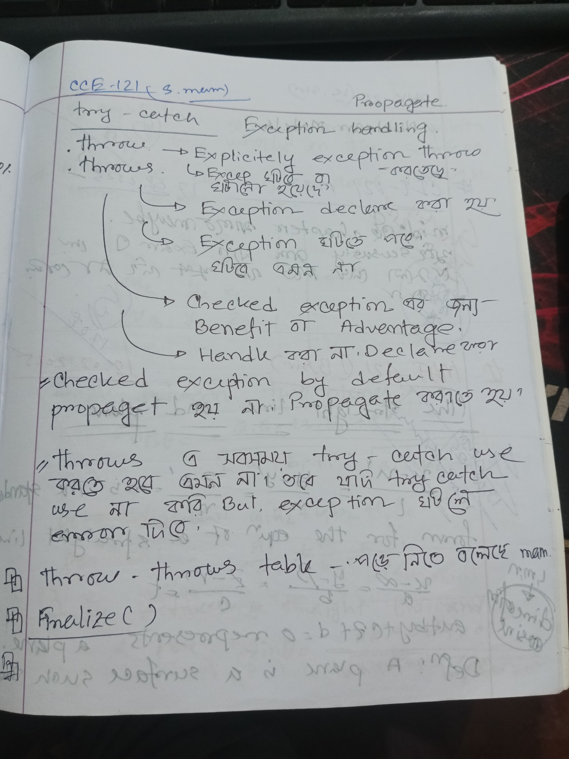

কীওয়ার্ড | কাজ
try | ঝুঁকিপূর্ণ কোড এখানে রাখা হয়
catch | exception ধরার জন্য
finally | সবসময় execute হয়, exception ঘটুক বা না ঘটুক
throw | ম্যানুয়ালি exception তৈরি করতে ব্যবহার হয়
throws | কোন মেথড exception ছুঁড়তে পারে তা declare করতে

try-catch block
try Block:
The Java try block is used to enclose the code that might throw an exception. It must be used within the method.
If an exception occurs at a particular statement in the try block, the rest of the block code will not execute. So, it is recommended not to keep the code in a try block that will not throw an exception.
catch Block:
Java catch block is used to handle the Exception by declaring the type of exception within the parameter. The declared exception must be the parent class exception (i.e., Exception) or the generated exception type. However, a good approach is to declare the kind of exception generated.
The catch block must be used after the try block only. You can use multiple catch blocks with a single try block.
The Java try block must be followed by either a catch or a finally block.
Syntax of try-catch Block
- try {
- // code that may throw an exception
- } catch(Exception_class_Name ref) { }
Syntax of try-finally Bock
- try {
- // code that may throw an exception
- } finally { }

The JVM firstly checks whether the exception is handled or not. If an exception is not handled, JVM provides a default exception handler that performs the following tasks:
- Prints the exception description.
- Prints the stack trace (Hierarchy of methods where the exception occurred).
- Causes the program to terminate.
But if the programmer handles the exception, the normal flow of the application is maintained, i.e., rest of the code is executed.

Working of try-catch Block
- The Java Virtual Machine begins running the code that is enclosed in the try block.
- Should an exception arise, the JVM begins searching for the corresponding catch block and skips the rest of the code in the try block.
- The code in the catch block is run if a matching catch block is found.
- If there is a finally block, control shifts to it after the catch block.
- The default exception handler in the JVM is notified if no catch block matches.
- After the try-catch block, the final block is run. And whether or not there is an exception.

Multiple Catch Block

multiple catch blocks allow us to handle different types of exceptions separately. It is beneficial when a single try block contains code that may throw different types of exceptions.
Therefore, a try block can be followed by one or more catch blocks. Each catch block must contain a different exception handler. So, if we have to perform various tasks at the occurrence of other exceptions, use the multi-catch block.
Alternatively, we can separate each exception with | (pipe) symbol in a single catch block.
Catching multiple exceptions in a single catch block reduces code duplication and increases efficiency.

Syntax:
- try {
- //code that may throw exception
- }
- catch (Exception1 | Exception2 | Exception3 | Exception4 e) {
- // Common handling logic for multiple exceptions
- }
or
- try {
- //code that may throw exception
- }
- catch(Exception1 e1) {
- //handle exception code
- }
- catch(Exception2 e2) {
- //handle exception code
- }
- catch(Exception3 e3) {
- //handle exception code
- }
- catch (Exception e) {
- // Handle any other exceptions (General exception block)
- }

Note:
- At a time only one exception occurs and at a time only one catch block is executed.
- All catch blocks must be ordered from most specific to most general, i.e. catch for ArithmeticException must come before catch for Exception. (যদি আগে most general দেন আর পরে most specific দেন, তাহলে compile-time error হবে।
Note:
When the try block contains multiple exceptions, then its handled only the first occurring exception.

Nested Try Block
try block inside another try block is called as nested try block. Every statement that we enter a statement in try block, context of that exception is pushed onto the stack.
For example, the inner try block can be used to handle ArrayIndexOutOfBoundsException, while the outer try block can handle the ArithmeticException (division by zero).
যখন try ব্লকের ভেতরে কোনো statement exception তৈরি করে, তখন সেই exception-এর তথ্য (context) JVM একটি stack-এ push করে।
এখানে stack বলতে বোঝানো হচ্ছে exception stack trace।
Stack trace কী?
- Java যখন কোনো exception throw করে, তখন সেটা শুধু message দেয় না—
- বরং কোথায়, কোন method-এ, কোন line number-এ exception ঘটেছে—সব তথ্য একটা stack trace আকারে রাখে।
- এই তথ্যগুলো JVM একটা call stack-এ জমা রাখে।

Exception in thread "main"java.lang.ArithmeticException: / by zero
at Test.method2(Test.java: 11)
at Test.method1(Test.java: 7)
at Test.main(Test.java: 3)

এখানে exception হলে JVM একটা stack trace প্রিন্ট করেছে—
- প্রথমে কোথায় exception ঘটল (method2)
- তারপর কে ডাকল (method1)
- তারপর কে ডাকল (main)
এই ট্র্যাকিংটাই হচ্ছে "context pushed onto the stack"।
সহজ ভাষায়:
যখন exception হয়—
- JVM সেই সময়ের execution history (method calls, line numbers, exception type ইত্যাদি) stack-এ জমা রাখে।
- এটাকেই বলে "exception context pushed onto the stack"।

We use nested try-catch block, because Sometimes a situation may arise where a part of a block may cause one error and the entire block itself may cause another error. In such cases, exception handlers have to be nested.

Syntax:
- try {
- // Outer try block
- try {
- // Inner try block
- } catch (ExceptionType1 e1) {
- // Inner catch block
- }
- } catch (ExceptionType2 e2) {
- // Outer catch block
- }

Example: Handling Two Different Exceptions
- public class Main {
- public static void main(String args[])
- {
- //outer try block
- try {
- //inner try block 1
- try {
- System.out.println("cannot divide by 0");
- int b =39/0;
- }
- //catch block of the inner try block 1
- catch(ArithmeticException e)
- {
- System.out.println(e);
- }
- //inner try block 2
- try{
- int a[]=new int[5];
- //assigning the value out of array bounds
- a[5]=4;
- }
- //catch block of the inner try block 2
- catch(ArrayIndexOutOfBoundsException e)
- {
- System.out.println(e);
- }
- System.out.println("other statement");
- }
- //catch block of the outer try block
- catch(Exception e)
- {
- System.out.println("handled the exception (outer catch)");
- }
- System.out.println("normal flow..");
- }
- }
Output:
cannot divide by 0
java.lang.ArithmeticException: / by zero
java.lang.ArrayIndexOutOfBoundsException: Index 5 out of bounds for length 5
other statement
normal flow..

When any try block does not have a catch block for a particular exception, then the catch block of the outer (parent) try block is checked for that exception, and if it matches, the catch block of the outer try block is executed.
If none of the catch blocks specified in the code are able to handle the exception, then the Java runtime system will handle the exception. Then, it displays the system-generated message for that exception.

Example: Handling Exception by the Main try Block
- public class Main {
- public static void main(String args[])
- {
- // outer (main) try block
- try {
- //inner try block 1
- try {
- // inner try block 2
- try {
- int arr[] = { 1, 2, 3, 4 };
- //printing the array element out of its bounds
- System.out.println(arr[10]);
- }
- // to handle ArithmeticException
- catch (ArithmeticException e) {
- System.out.println("Arithmetic exception");
- System.out.println(" inner try block 2");
- }
- }
- // to handle ArithmeticException
- catch (ArithmeticException e) {
- System.out.println("Arithmetic exception");
- System.out.println("inner try block 1");
- }
- }
- // to handle ArrayIndexOutOfBoundsException
- catch (ArrayIndexOutOfBoundsException e4) {
- System.out.print(e4);
- System.out.println(" outer (main) try block");
- }
- catch (Exception e5) {
- System.out.print("Exception");
- System.out.println(" handled in main try-block");
- }
- }
- }

Output:
java.lang.ArrayIndexOutOfBoundsException: Index 10 out of bounds for length 4 outer (main) try block
Let's consider the following example. Here, the try block within the nested try block (inner try block 2) does not handle the exception. The control is then transferred to its parent try block (inner try block 1). If it does not handle the exception, then the control is transferred to the main try block (outer try block), where the appropriate catch block handles the exception. It is termed as nesting.

finally Block
finally block is a block used to execute important code, such as closing the connection etc.
Java finally block is always executed, whether an exception is handled or not. Therefore, it contains all the necessary statements that need to be printed regardless of whether an exception occurs or not.
The finally block follows the try-catch block.
Flowchart of the finally block
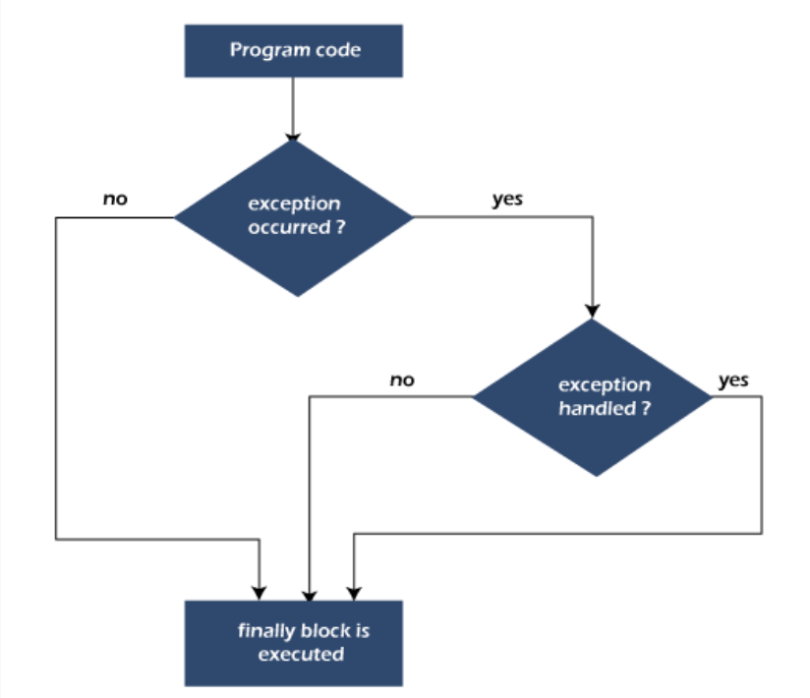

Note: If we do not handle the exception before terminating the program, the JVM executes the finally block (if any).

Why use a Java finally block?
- finally block in Java can be used to put "cleanup" code, such as closing a file, closing a connection, etc.
- The important statements to be printed can be placed in the finally block.

Usage of the finally Block

Case 1: When an exception does not occur – [ try -> final -> rest ]

Case 2: When an exception occurs but is not handled by the catch block – [ try -> final -> JVM error ]

Case 3: When an exception occurs and is handled by the catch block – [ try -> catch(user print + Exception msg) -> final -> rest ]

Note: The finally block will not execute if the program exits (either by calling System.exit() or by causing a fatal error that causes the process to abort).

1  2  3  4  5  6  7  8  9  10  11  12 | public class Test {  public static void main(String[] args) {  try {  System.out.println("Inside try block");  System.exit(0); // JVM কে এখানেই বন্ধ করে দেয়  } catch (Exception e) {  System.out.println("Inside catch block");  } finally {  System.out.println("Inside finally block");  }  }  }

Output:
Inside try block

throw keyword
throw keyword is used to throw an exception explicitly from a method or block of code.
It allows developers to signal that an error has occurred and needs to be handled. It provides developers with a way to trigger an exception whenever a particular undesirable situation occurs manually.
The thrown exception must be an instance of Throwable or one of its subclasses, such as Exception or RuntimeException. It can be used to throw both checked and unchecked exceptions. It is mainly used to throw a custom exception.
We specify the exception object that is to be thrown. The Exception has a message with it that provides the error description. These exceptions may be related to user inputs, server, hardware malfunctions, invalid computations, or many other conditions, depending on the program's requirements.
We can also define our own set of conditions and throw an exception explicitly using the throw keyword. For example, we can throw an ArithmeticException if we divide a number by another number.

Syntax:
throw new exception_class("error message");
Here:
- new is used to create an instance (object) of the exception class.
- The error message provides context about the reason for the exception.
Where the Instance must be of type Throwable or a subclass of Throwable, for example, Exception is a subclass of Throwable, and the user-defined exceptions usually extend the Exception class.

example of throw IOException:
throw new IOException("sorry device error");

Key Requirements
- The object we throw must be of type Throwable or one of its subclasses.
- For example, Exception is a subclass of Throwable.
- User-defined exceptions (also known as custom exceptions) usually extend the Exception class.
- If you throw a checked exception and do not handle it inside the method, you must declare it using the throws keyword in the method signature.

Example
- import java.lang.ArithmeticException;
- public class Main {
- // Function to check if a person is eligible to vote or not
- public static void validate(int age) {
- if(age < 18) {
- // Throw ArithmeticException if not eligible to vote
- throw new ArithmeticException("Person is not eligible to vote");
- } else {
- System.out.println("Person is eligible to vote!!");
- }
- }
- // Main method
- public static void main(String args[]) {
- // Calling the function
- validate(13);
- System.out.println("rest of the code...");
- }
- }

Output:
Exception in thread "main" java.lang.ArithmeticException: Person is not eligible to vote
at Main.validate(Main.java:8)
at Main.main(Main.java:17)

Note: If we throw an unchecked exception from a method, it is not required to handle the exception or declare it in a throws clause. However, for checked exceptions, handling or declaration in the throws clause is mandatory."

If we throw a checked exception using the throw keyword, it is a must to handle the exception using the catch block, or the method must declare it using the throws declaration.
In Java, checked exceptions are exceptions that the compiler requires you to either handle using a try-catch block or declare using the throws keyword in the method signature. These exceptions typically arise from external sources such as file operations, network connections, or database access operations that are prone to failure.
Unlike unchecked exceptions (which are subclasses of RuntimeException), checked exceptions are subclasses of Exception (but not of RuntimeException).
Note: Every subclass of Error and RuntimeException is an unchecked exception in Java. A checked exception is everything else under the Throwable class.

Example: Throwing a Checked Exception
- import java.io.*;
- public class Main {
- //function to check if a person is eligible to vote or not
- public static void method() throws FileNotFoundException {
- FileReader file = new FileReader("C:\\Users\\Desktop\\abc.txt");
- BufferedReader fileInput = new BufferedReader(file);
- // Explicitly throwing a checked exception
- throw new FileNotFoundException();
- }
- //main method
- public static void main(String args[]){
- try {
- method();
- }
- catch (FileNotFoundException e) {
- e.printStackTrace();
- }
- System.out.println("rest of the code...");
- }
- }

Output:
java.io.FileNotFoundException: C:\Users\Desktop\abc.txt (No such file or directory)
at java.base/java.io.FileInputStream.open0(Native Method)
at java.base/java.io.FileInputStream.open(FileInputStream.java:213)
at java.base/java.io.FileInputStream.<init>(FileInputStream.java:152)
at java.base/java.io.FileInputStream.<init>(FileInputStream.java:106)
at java.base/java.io.FileReader.<init>(FileReader.java:60)
at Main.method(Main.java:9)
at Main.main(Main.java:20)

Throwing User-Defined Exception:
Java allows developers to create their own custom exceptions by extending the Exception class or one of its subclasses. These are known as user-defined exceptions. They are typically used when you want to enforce application-specific rules and constraints that are not covered by Java's built-in exceptions.

Example
- import java.io.*;
- // class represents a user-defined exception
- class UserDefinedException extends Exception {
- public UserDefinedException(String str) {
- // Calling the constructor of the parent Exception
- super(str);
- }
- }
- // Class that uses the above MyException
- public class Main {
- public static void main(String args[]) {
- try {
- // throw an object of user user-defined exception
- throw new UserDefinedException("This is user-defined exception");
- }
- catch (UserDefinedException ude) {
- System.out.println("Caught the exception");
- // Print the message from the MyException object
- System.out.println(ude.getMessage());
- }
- }
- }

Output:
Caught the exception
This is a user-defined exception

Exception Propagation
An exception is first thrown from the top of the stack and if it is not caught, it drops down the call stack to the previous method. If not caught there, the exception again drops down to the previous method, and so on until they are caught or until they reach the very bottom of the call stack. This is called exception propagation.
Note: By default Unchecked Exceptions are forwarded in calling chain (propagated).[ যখন কোনো unchecked exception (যেমন ArithmeticException, NullPointerException) ঘটে, তখন যদি সেই মেথডে তাকে handle (try–catch) না করা হয়, তবে সেটি আপনি কিছু না লিখলেও (by default) কল করা মেথডে চলে যাবে।
অর্থাৎ, এক মেথড থেকে আরেক মেথডে স্বয়ংক্রিয়ভাবে exception propagate হয়। যদি কোথাও catch না করা হয়, তবে শেষ পর্যন্ত JVM exception ধরবে আর প্রোগ্রাম বন্ধ হয়ে যাবে। ]
• Checked exception → declare বা handle না করলে error দেবে।
• Unchecked exception → declare না করলেও চলে, default ভাবে propagate হয়।

Example:
class TestExceptionPropagation1 {
void m() {
int data = 50 / 0;
}

void n() {
m();
}

void p() {
try {
n();
} catch (Exception e) {
System.out.println("exception handled");
}
}

public static void main(String args[]) {
TestExceptionPropagation1 obj = new TestExceptionPropagation1();
obj.p();
System.out.println("normal flow...");
}
}
Output:
exception handled
normal flow...

In the above example exception occurs in the m() method where it is not handled, so it is propagated to the previous n() method where it is not handled, again it is propagated to the p() method where exception is handled.
Exception can be handled in any method in call stack either in the main() method, p() method, n() method or m() method.
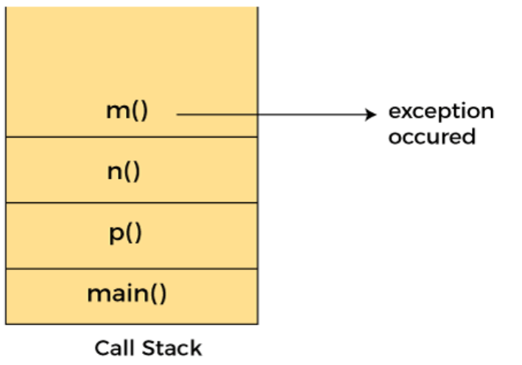
Note: By default, Checked Exceptions are not forwarded in calling chain (propagated). [
যদি কোনো মেথডে checked exception (যেমন IOException, SQLException) ঘটে এবং আপনি সেটা:
- handle (try–catch) না করেন, অথবা
- declare (throws keyword) না করেন
তবে সেটা উপরে caller method এ যাবে না।
]
void method1() {
throw new IOException("device error"); // Checked Exception
}

void method2() {
method1(); // এখানে declare বা handle না করলে error হবে
}
এখানে compiler বলবে:
unreported exception IOException; must be caught or declared to be thrown
✅ Checked exception propagate করতে চাইলে আপনাকে অবশ্যই প্রতিটি মেথডে হয় throws দিয়ে declare করতে হবে অথবা try-catch দিয়ে handle করতে হবে।
❌ Unchecked exception এর মতো এটা নিজের থেকেই propagate হয় না।
import java.io.IOException;

class Demo {

void method1() throws IOException {
throw new IOException("device error"); // Checked Exception
}

void method2() throws IOException {
method1(); // শুধু declare করা হলো, handle করা হয়নি
}

void method3() {
try {
method2(); // এখানে handle করলাম
} catch (IOException e) {
System.out.println("Exception handled in method3");
}
}

public static void main(String[] args) {
Demo obj = new Demo();
obj.method3();
System.out.println("Normal flow continues...");
}
}

যদি method2() এ শুধু throws IOException লিখে দেন, কিন্তু সেখানে handle না করেন, তাহলেও কোনো সমস্যা নেই।
👉 কারণ throws মানে হলো —
"আমি handle করলাম না, responsibility দিলাম আমার caller method-কে।"
তাহলে method3() যদি method2() কে কল করে, সেখানে try-catch ব্যবহার করলেই exception সেখানে handle হয়ে যাবে।

Exception Propagation Example
- class TestExceptionPropagation2{
- void m(){
- throw new java.io.IOException("device error");//checked exception
- }
- void n(){
- m();
- }
- void p(){
- try{
- n();
- }catch(Exception e){System.out.println("exception handeled");}
- }
- public static void main(String args[]){
- TestExceptionPropagation2 obj=new TestExceptionPropagation2();
- obj.p();
- System.out.println("normal flow");
- }
- }
Output:
Compile Time Error

throws keyword
throws keyword is used in method declarations. It specifies the exceptions that a method might throw during execution. Therefore, the programmer should provide exception handling code or propagate the exception to maintain the normal flow of the program.
Exception Handling is mainly used to handle the checked exceptions. If there occurs any unchecked exception occurs, such as NullPointerException, it is the programmer's fault that he is not checking the code before it is used.

Syntax
- return_type method_name() throws exception_class_name{
- //method code
- }
Example:
1  2  3  4  5  6  7  8  9  10  11  12  13  14  15  16  17  18  19  20  21 | import java.io.IOException;  class Main {  void m() throws IOException {  throw new IOException("device error"); //checked exception  }  void n() throws IOException {  m();  }  void p() {  try {  n();  } catch (Exception e) {  System.out.println("exception handled");  }  }  public static void main(String args[]) {  Main obj = new Main();  obj.p();  System.out.println("normal flow...");  }  }
Output:
exception handled
normal flow...

NOTE: If an exception is declared in an inner (called) method, then every method in the call chain must either:
- Declare the exception using throws, or
- Handle it using a try-catch block
This continues until the point where the exception is actually handled. Once the exception is caught inside a try-catch, you don’t need to declare it with throws in the methods above.
Rule: (Jeta ami upore likheci) If we are calling a method that declares an exception, we must either catch or declare the exception.
There are the following two cases:
Case 1: We have caught the exception, i.e. we have handled the exception using a try/catch block.
Case 2: We have declared the exception, i.e. specified throws keyword with the method.
- If we declare an exception and it does not occur, the code will execute correctly.
- If we declare the exception and it does occur, it will be thrown at runtime, as the throws keyword does not manage the exception.
A) If an exception does not occur

Example
- import java.io.*;
- class M{
- void method()throws IOException {
- System.out.println("Device operation performed");
- }
- }
- class Main {
- public static void main(String args[])throws IOException{//declare exception
- M m=new M();
- m.method();
- System.out.println("normal flow...");
- }
- }

Output:
Device operation performed
normal flow...

B) If an exception occurs

Example
- import java.io.*;
- class M{
- void method()throws IOException{
- throw new IOException("device error");
- }
- }
- class Main{
- public static void main(String args[])throws IOException{//declare exception
- M m=new M();
- m.method();
- System.out.println("normal flow...");
- }
- }
When we run the above code, we get the following exception
Output:
Exception in thread "main" java.io.IOException: device error
at M.method(Main.java:4)
at Main.main(Main.java:10)

Difference Between throw and throws

Important Points to Remember

throw keyword
- It throws an exception object.
- It is used when we want to manually raise an exception.
- It is used inside method.
For example,
- throw new IllegalArgumentException("Invalid input");

throws keyword
- It declares that a method might throw one or more exceptions.
- It is used when method contains code that may throw a checked exception, and we want the caller to handle it.
- It is used with method signature.
For example,
- public void readFile() throws IOException {
- // code that might throw IOException
- }
throw keyword:
The "throw" keyword in Java is used to explicitly throw an exception. It disrupts the normal flow of the program by transferring control to the nearest catch block that can handle the thrown exception. When an exception occurs within a method, the method creates an exception object and throws it using the "throw" keyword.

Example: Use of throw Keyword

Example
- public class Main {
- // defining a method
- public static void checkNum(int n) {
- if (n < 1) {
- throw new ArithmeticException("\nNumber is negative, cannot calculate square");
- } else {
- System.out.println("Square of " + n + " is " + (n * n));
- }
- }
- // main method
- public static void main(String[] args) {
- Main obj = new Main();
- obj.checkNum(-3);
- System.out.println("Rest of the code..");
- }
- }
Output:
Exception in thread "main" java.lang.ArithmeticException:
Number is negative, cannot calculate square
at Main.checkNum(Main.java:5)
at Main.main(Main.java:13)

throws keyword:
On the other hand, the "throws" clause is used in method signatures to indicate that the method may throw certain types of exceptions during its execution. It does not actually throw the exception; instead, it declares that the method may throw exceptions of specified types, thereby alerting the caller to handle them appropriately.

Example: Use of throws Keyword

Example
- public class Main {
- // defining a method
- public static int divideNum(int m, int n) throws ArithmeticException {
- int div = m / n;
- return div;
- }
- // main method
- public static void main(String[] args) {
- Main obj = new Main();
- try {
- System.out.println(obj.divideNum(45, 0));
- } catch (ArithmeticException e) {
- System.out.println("Number cannot be divided by 0");
- }
- System.out.println("Rest of the code..");
- }
- }
Output:
Exception caught: Number is negative, cannot calculate square
Rest of the code...

Example: Use of throw and throws Keyword

Example
- public class Main {
- // creating a user-defined function that raises an ArithmeticException
- static void method() throws ArithmeticException {
- System.out.println("Inside the method()");
- throw new ArithmeticException("Throwing ArithmeticException");
- }
- // main method
- public static void main(String args[]) {
- try {
- method();
- } catch (ArithmeticException err) {
- System.out.println("Caught in main() method");
- }
- }
- }

Output:
Inside the method()
Caught in main() method

throw vs throws:
Characteristics | throw | throws
Definition | Java throw keyword is used throw an exception explicitly in the code, inside the function or the block of code. | Java throws keyword is used in the method signature to declare an exception which might be thrown by the function while the execution of the code.
Declaration | It is used inside a method or block. | It is used with method signature.
Usage | Type of exception using throw keyword, we can only propagate unchecked exception i.e., the checked exception cannot be propagated using throw only. | Using throws keyword, we can declare both checked and unchecked exceptions. However, the throws keyword can be used to propagate checked exceptions only.
Purpose | It triggers the creation and throwing of an exception. | It informs the caller of the method about possible exceptions may occur.
Syntax | throw new ExceptionType("message"); | public void myMethod() throws IOException
Number of Exceptions | It can throw only one exception at a time. | It can declare multiple exceptions separated by commas.
Followed By | An instance of Throwable (or subclass). | One or more exception classes (checked exception only).
Internal Implementation | We are allowed to throw only one exception at a time i.e. we cannot throw multiple exceptions. | We can declare multiple exceptions using throws keyword that can be thrown by the method. For example, main() throws IOException, SQLException.

Difference between final, finally and finalize
- final is an access modifier
- finally is the block in Exception Handling
- finalize is the method of the object class

final Keyword
A final is a keyword used to restrict changes. A final variable cannot be reassigned, a final method cannot be overridden, and a final class can't be subclassed. It ensures immutability and is often used for constants.

Characteristics of final Keyword
- Used to declare constants: A final variable's value cannot be changed once assigned.
- Prevents method overriding: A final method cannot be overridden in a subclass.
- Restricts inheritance: A final class cannot be extended by any other class.

Example
- public class Main {
- //declaring final variable
- final int age = 18;
- void display() {
- // reassigning value to age variable
- // gives compile time error
- age = 55;
- }
- public static void main(String[] args) {
- Main obj = new Main();
- // gives compile time error
- obj.display();
- }
- }
When we compile the above program, we get the following error.
Output:
Main.java:7: error: cannot assign a value to final variable age
age = 55;
^
1 error

finally Block
A finally is a block used with try-catch statements to execute important code like closing resources. It always runs whether an exception occurs or not, ensuring cleanup actions are performed.

Characteristics of finally
- Part of exception handling: Used with try and catch blocks.
- Always executes: Runs regardless of whether an exception is thrown or caught.
- Used for resource cleanup: Like closing files, database connections, etc.

Example
- public class Main {
- public static void main(String args[]){
- try {
- System.out.println("Inside try block");
- //The below code throws a divide by zero exception
- int data=25/0;
- System.out.println(data);
- }
- // handles the Arithmetic Exception / Divide by zero exception
- catch (ArithmeticException e){
- System.out.println("Exception handled");
- System.out.println(e);
- }
- // executes regardless of exception occurred or not
- finally {
- System.out.println("finally block is always executed");
- }
- System.out.println("rest of the code...");
- }
- }
Output:
Inside try block
Exception handled
java.lang.ArithmeticException: / by zero
finally block is always executed
rest of the code...

finalize() Method
A finalize() is a method called by the garbage collector before an object is destroyed. It's used to perform cleanup operations like releasing resources, but it is deprecated and not recommended in modern Java.

Characteristics of finalize() Method
- Defined in java.lang.Object class: Can be overridden by any class.
- Called by the garbage collector: Just before destroying an object.
- Used for cleanup: Freeing resources like file handles or network sockets.
- Not reliable: No guarantee it will be executed timely or at all.

Example
- public class Main {
- @Override
- protected void finalize() throws Throwable {
- System.out.println("finalize() method called before object is garbage collected.");
- }
- public static void main(String[] args) {
- Main obj = new Main();
- obj = null; // Eligible for garbage collection
- // Request JVM to run Garbage Collector
- System.gc();
- System.out.println("Main method completed.");
- }
- }
Output:
finalize() method called before object is garbage collected.
Main method completed.

final Vs. finally Vs. finalize() in Java
Aspect | final | finally | finalize()
Definition | final is the keyword and access modifier that is used to apply restrictions on a class, method or variable. | finally is the block in Java Exception Handling to execute the important code whether the exception occurs or not. | finalize is the method in Java that is used to perform cleanup processing just before an object is garbage collected.
Applicable to | The final keyword is used with the classes, methods and variables. | Finally block is always related to the try and catch block in exception handling. | The finalize() method is used with the objects.
Functionality | (1) Once declared, a final variable becomes a constant and cannot be modified.  (2) The final method cannot be overridden by sub class.  (3) The final class cannot be inherited. | (1) finally block runs the important code even if an exception occurs or not.  (2) The finally block cleans up all the resources used in a try block | The finalize() method performs the cleaning activities with respect to the object before its destruction.
Execution | The final method is executed only when we call it. | Finally block is executed as soon as the try-catch block is executed.  Its execution is not dependant on the exception. | The finalize() method is executed just before the object is destroyed.
Inheritance/Overriding | Prevents method overriding and class inheritance. | Not related to inheritance or overriding. | Can be overridden from the Object class.
Use Case | To create constants, prevent subclassing or method overriding. | To ensure resource cleanup, like closing files, streams, etc., in exception handling. | To perform cleanup activities like memory/resource release before the object is collected.
Control | Gives compile-time control to avoid unintended changes. | Provides runtime control to handle cleanup post-exception or normal flow. | Invoked by JVM (Java Virtual Machine); the programmer cannot call it directly for cleanup.
Example | final int x=10; | Finally{closeResource | protected void finalize

Exception Handling with Method Overriding
- If the superclass method does not declare an exception
  - If the superclass method does not declare an exception, subclass overridden method cannot declare the checked exception but it can declare unchecked exception.
- If the superclass method declares an exception
  - If the superclass method declares an exception, subclass overridden method can declare same, subclass exception or no exception but cannot declare parent exception.

Custom (User-Defined) Exception

Custom exceptions are derived classes of the Exception class. Custom exceptions are also known as user-defined exceptions. Basically, Java custom exceptions are used to customize the exception according to the user's requirement.
This exception extends either the Exception class or the RuntimeException class (for unchecked exceptions). Using the custom exception, we can have our own exception and message.
Syntax:
- public class WrongFileNameException extends Exception {
- public WrongFileNameException(String errorMessage) {
- super(errorMessage);
- }
- }

Example:
1  2  3  4  5  6  7  8  9  10  11  12  13  14  15  16  17  18 | // Custom exception (unchecked)  class NegativeNumberException extends RuntimeException {  public NegativeNumberException(String msg) {  super(msg);  }  }  public class SmallExample {  public static void main(String[] args) {  int num = -5;  if (num < 0) {  throw new NegativeNumberException("Negative number: " + num);  }  System.out.println("Number is: " + num);  }  }

Note: We need to write the constructor that takes a String as the error message, and it is called the parent class constructor.

